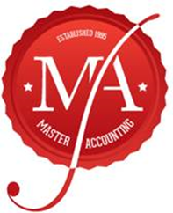
INTERVIEW SHEET

Name |  | TFN
Occupation |  | DOB
Address |  | Phone
Email |  | Preferred contact | Ph/SMS/Email/VC/Post
Spouse status |  | # dependents
Payment | Authority / Upfront | Quote
Refund account | Name | BSB | Acct#

INCOME | Y | N | DETAILS | $
Employment Income
Interest Income
Dividend Income
Rental Income

Business – Sole / Pship / Trust

Other Income
EXPENSES: WORK | Y | N |  |  | $

Car Expenses set rate $0.72/ logbook
5000 km reason trips too
Vehicle Registration/ Make/ Model
Details trips where km travel each trip
Travel Expenses

Uniform N/ C/ S / P
Laundry $1 wash only
Self-Educated Costs/Fees relate current job
Sun Protection
Home Office 45c hr / apportion only self employed
Phone %
Union Fees
Tools
Requisites
OTHER ITEMS
Interest / Dividend Deductions | Y | N |  | $
Donations
Tax Agent Fees
Income Protection Insurance
HECS / HELP debt
Private Health Cover
Super Cont. A3 Non-concessional
Spouse Taxable Income Details Name: D.O.B: Income:

Interviewed By …………………………. Date…………………

I am aware that substantiation of expenses & income is required by law and it is my responsibility to keep records for 5 years in case of an Audit. You are now an engaged client of Accountants and More our pricelist can be found at accountantsandmore.com.au

Signature: __________________________

